MOVIE ASSIGNMENT

1. Write a query in SQL to find the name and year of the movies.

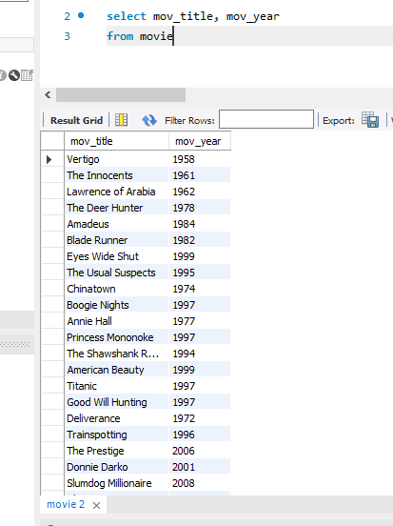

1. Write a query in SQL to find the year when the movie American Beauty released.

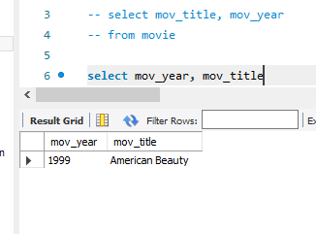

1. Write a query in SQL to find the movie which was released in the year 1999

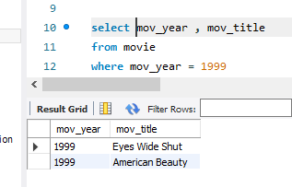

1. Write a query in SQL to find the movies which was released before 1998

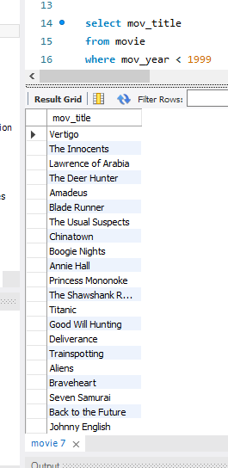

1. Write a query in SQL to find the movie which was released in the year 1999

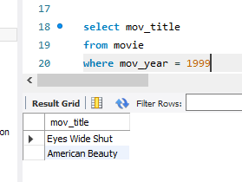

1. Write a query in SQL to return the name of all reviewers and name of movies together in a single list

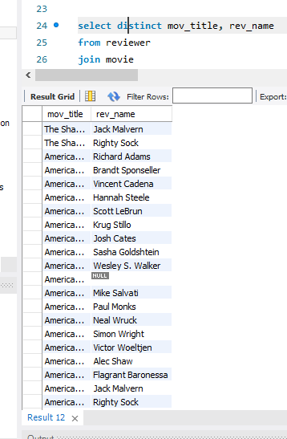

1. Write a query in SQL to find the name of all reviewers who have rated 7 or more stars to their rating

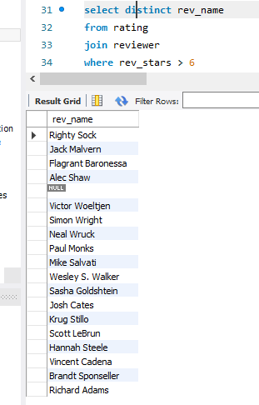

1. Write a query in SQL to find the titles of all movies that have no ratings.

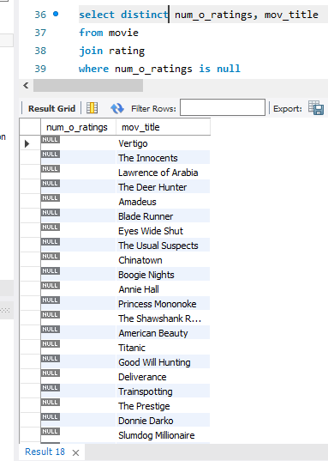

1. Write a query in SQL to find the name of all reviewers who have rated their ratings with a NULL value

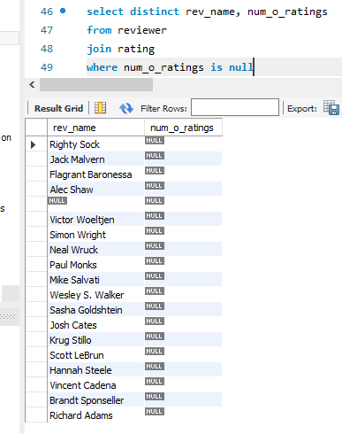

1. Write a query in SQL to find the name of movie and director (first and last names) who directed a movie that casted a role for 'Eyes Wide Shut'.